**Kol simcha torah gazette**

**For rosh hashanah 5784**

(Issue #1) 1-2 Tishrei 5783/ September 16-17, 2023

**Printed L’illuy nishmas Nechama bas R’ Noach, a”h**

For a free subscription, please forward your request to [***keren18@juno.com***](mailto:keren18@juno.com)

**Rosh Hashanah Reflections on the Shofar**



“All Shofarot are kosher except for the horn of an ox . . . [The sage] Abaye states: ‘The Torah says to blow one Shofar, not two or three Shofarot. The horn of an ox consists of multiple layers and looks like two or three Shofarot; therefore, it may not be used for the Mitzvah’.” (Rosh Hashanah 26a)

Rashi z”l explains: Every year, another layer of growth is visible on the ox’s horn.

R’ Avraham Moshe Rabinowitz (Skolya Rebbe in Brooklyn, N.Y.) writes: The Gemara (Rosh Hashanah 18a) teaches that, on Rosh Hashanah, Hashem surveys all of mankind at once, sees what is in the heart of each person, and notices all of each person’s actions. [Until here from the Gemara.]

This means, writes R’ Dovber Schneerson z”l (1773-1827; second Lubavitcher Rebbe) that Hashem’s judgment takes into account, all at once, man’s past, his present state, and even his future.

Therefore, explains the Skolya Rebbe, the horn of an ox, on which the passage of individual years is visible, is inappropriate for use as a Shofar on Rosh Hashanah. The Skolya Rebbe continues: We say in the Rosh Hashanah prayers, “This day is the beginning of Your creation,” a reference to the fact that man was created on Rosh Hashanah.

The Torah relates (Bereishit 2:7), “Hashem Elokim formed the man out of dust from the ground, and He blew into his nostrils the soul of life.” In every generation, for all time, the one who blows the Shofar is, in a sense, continuing the “breath” that Hashem “blew” on that first Rosh Hashanah. Like Hashem’s “breath,” every breath into the Shofar has an impact on all future generations, albeit unseen by us. [The person who blows connects past, present, and future through the Shofar.]

Only Hashem can be aware of everything–much less, survey it all at once. As for man, the Skolya Rebbe quotes R’ Avigdor Miller z”l (1908-2001; rabbi, educator and author; considered one of the first American-born “Gedolim”), who notes that everything a person experiences through any of his five senses is stored in his memory forever, albeit subconsciously. Moreover, a person is taking in new sensations every instant of every day. But, not all sensations are equal.

For example, the fear of G-d that one learns from a book is not comparable to the fear of G-d that he learns from watching his teacher, because the latter is a living, multi-sensory experience, while the former is not; it is merely information.

This is why the Gemara (Berachot 7b) states that serving a Torah scholar is greater than studying Torah. Man’s task, concludes R’ Miller, is to take in as many experiences as possible that strengthen his belief that Hashem directs His world, observes and considers everything, and rewards those who fear Him. [Until here from R’ Miller.]

Rambam z”l writes that the Shofar calls to a person to awaken and to remember that which he has forgotten. [Thus, the Shofar brings the past into the present and influences the future, so it should be one piece.] (Hadrat Melech p.47 - Hamaayan)

*Reprinted from the Parshat Netzavim-Vayelech 5783 email of R’ Yedidya Hirtenfeld’s whY I Matter parsha sheet for the Young Israel of Midwood in Brooklyn.*

**A Lesson from Chana in Making Our Personal Needs G-d’s Needs**

**From the Teachings of the Lubavitcher Rebbe**

**Rabbi Menachem Mendel Schneerson, Zt”l**

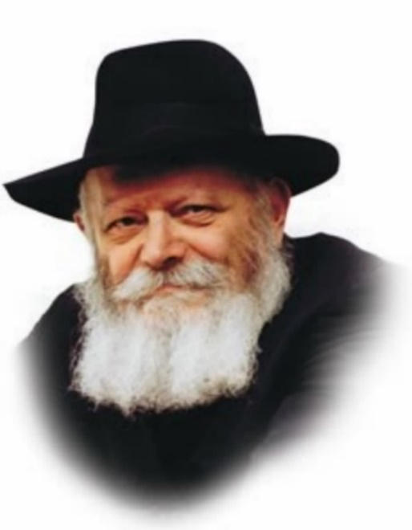

The haftora of the first day of Rosh Hashana relates the story of Chana. Chana, who was childless, came to the Sanctuary to pray. In the merit of her prayers, she was blessed with a son, the prophet Shmuel (Samuel).

When Eli the priest saw Chana so immersed in her prayers that she seemed to be oblivious to her surroundings, he suspected her of being drunk. The Midrash explains that Eli suspected her of being "drunk" in the act of praying.

"I am pouring out my soul before G-d," Chana replied. I am not praying simply for the sake of praying; my soul is uniting with G-d.

On Rosh Hashana, the Day of Judgment, we appeal to G-d to fulfill our spiritual and material needs. We ask Him for healthy children, long lives, and an abundant livelihood.

Rosh Hashana is also the day of G-d's coronation as King. We accept His sovereignty by nullifying ourselves before Him. When we are completely nullified, we are not aware of our personal wants and desires. Our sense of self is superseded by the awareness of being in G-d's Presence.

This presents us with a seeming contradiction. If Rosh Hashana is characterized by a nullification of self, how can we simultaneously pray for the fulfillment of our personal requests?

To explain:

When a Jew prays to G-d on Rosh Hashana, his prayer is an extension of the process of coronation. While he may be asking G-d for material blessings, his true intention - whether consciously or unconsciously - is the desire to spread awareness of G-d's kingship in the world. On the deepest level, the physical body is a medium through which we establish a dwelling place for G-d in this world. By praying for material blessing, the Jew is asking for Divine assistance in fulfilling his G-dly mission.

It was this concept that was misunderstood by Eli. His contention was that when a Jew prays, his awareness of being in G-d's Presence should preclude him from making personal requests. When he saw Chana praying for a son, he mistakenly concluded that she had forgotten G-d's Presence in the Sanctuary.

Not so, was Chana's reply. My desire for a son is not a personal desire, but a wish to be able to fulfill my greater mission in life. Without a son, my soul cannot serve G-d properly. Indeed, this is evident in the vow Chana made, that if G-d blessed her with a child, she would give him over to the priest for a life of total dedication to Divine service. Chana wasn't asking G-d to fulfill her personal request; she was praying for G-d to fulfill His own needs!

So too is it with us on Rosh Hashana. Our petitions may be personal in focus, but their true essence is the soul's communication with G-d.

In the same way that G-d answered Chana's prayer, so too may He accede to our requests and grant the entire Jewish people a good and sweet year to come.

*Reprinted from the Rosh Hashanah 5761/2000 edition of L’Chaim. (Adapted from Volume 19 of Likutei Sichot.)*

**A Cry from the Heart**

An analogy is given to explain the sounding of the shofar on Rosh Hashana: There was once a king who sent his only son to a distant land to learn about its peoples and customs. As time passed, the prince's royal garb became faded and torn, and he even forgot how to speak his native tongue.

One day the prince heard that his father, the king, would be visiting the region. "How will I be able to approach him?" he thought to himself. "My clothes are torn, and I cannot speak the language."

The son decided that he would simply call out to his father in a cry without words, emanating from the heart, which the king would surely recognize. This is the call of the shofar, which appeals to the King's very Essence. *(The Baal Shem Tov)*

*Reprinted from the Rosh Hashanah 5761/2000 edition of L’Chai*

**Rav Avigdor Miller on**

**Pre-Rosh Hashanah Resolutions**

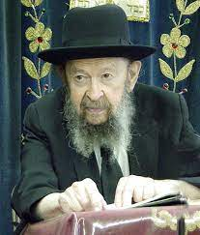

**QUESTION:** Every year, before Rosh Hashana comes along, I make **kabolos,**resolutions, about improving myself in various areas of my service of Hashem. But here I am a week before another Rosh Hashanah, the same **schlepper**I’ve always been.

**ANSWER:** Let me tell you something. You’re not the same. Don’t think you’re the same. You’re getting worse! As time goes on עבר אדם עבירה ושנה בה נעשית לו כהיתר – One who does a sin, and then repeats it again and again, it becomes permissible in his eyes (Yoma 87a). So, if you’re not improving, you’re getting worse.

When you make a kabalah bli neder you have to have something specific; at least one specific thing that you’re going to work on changing. תפסת מרובה לא תפסת – If you try to grab too much at one time, you’re going to grab nothing at all. It’s all going to fall out of your hand. To say in general, “I’m going to be good this year,” is better than nothing, but not much better.

You have to specify something clear cut. Say, “This year, no matter how mean my wife is to me, and how much she’ll bother me and criticize me and nag me, I won’t say anything impolite to her. I’ll keep my mouth closed.” That’s already something specific, something you can grab on to. תפסת מועט תפסת – It’s something limited, it’s something that you can grab onto.

And actually, even though it’s something specific, it’s not so small in Hashem’s eyes. The possuk says תולה ארץ על בלימה – “The world hangs on nothing”  (Iyov 26:7). And Chazal tell us that it means the following: אין העולם מתקיים אלה בשביל מי שבולם פיו בשעת מריבה – The world exists only on account of the person who keeps his mouth closed at a time of provocation (Chulin 89a).

The zchus, the merit, of keeping your mouth closed when people are insulting you is a very big zchus. So, start with your wife. You can start with somebody else as well. Let’s say you have an employer who insults you, keep quiet. You want to keep your job don’t you? So, keep your mouth closed. Make a kabalah, “I’m going to keep quiet. I won’t answer back.” It’s a tremendous thing to do that.

So, you have to pinpoint something clear cut. And then you’ll be able to carry it out. Don’t talk in general. General means nothing at all.

Let’s say you want to daven with kavanah. You can’t just say,  “This year, I’m going to daven with kavanah.” It’s too much to grab onto at once. Make up your mind that you’re going to fight to get that first bracha. Every word in מגן אברהם, that first bracha you’re going to get down clearly. And don’t let go of it. Hold on to it. תפסת מועט תפסת – Take a little bit at a time and hold on to it. תפסת, means that you’re grabbing on to it. Hold on to that little bit very tightly.

Let’s say you made a kabalah to learn Torah. So don’t say, “I’m going to start learning more seriously this year.” It’s too big, too vague. Do it like this: “Bli neder, I’m going to learn fifteen minutes every day no matter what.” And then, do it. Learn every night, fifteen minutes; it’s better than nothing. At home, fifteen minutes. No matter what! Take out a sefer and learn for fifteen minutes. You want to learn an hour, very good, I’m not stopping you. But every night, learn fifeeen minutes. Or go to a shiur every night. That’s even better. Every night no matter what. That’s a kabalah that’s a דבר שיש בו ממש; it’s clear-cut, it’s something you can sink your teeth into.

Now, even though sometimes there’s so many more things that you should be doing that you’re not doing, but at least there’s one thing you are doing. And Hashem sees that you’re headed in the right direction. And if you’re headed in the right direction then הבא ליטהר מסעיין אותו – If you’re trying to get better, He’ll help you go further and further (Menachos 29b). But you have to at least do one thing! And then you’ll get siyayta dishmaya to do more and more.

*Excerpted from a Parshas a recent email of Toras Avigdor based on Rabbi Avigdor Miller’s Tape #E-157 (September 1998) from his classic Thursday night lectures.*

**Thoughts that Count**

**for Rosh Hashanah**

**The Shofar as a Wake-Up Call**

The shofar is sounded on Rosh Hashana because it is an explicit commandment in the Torah. Nonetheless, it seems to convey a hidden message: "Wake up from your slumber!" it arouses us.

"Return to G-d and remember your Creator! To those who forget the truth and waste most of the year in frivolity and foolishness, look into your souls, improve your behavior, and correct your negative ways." *(Maimonides)*

**"For You remember everything that is forgotten..."**

A Chasidic sage once noted: G-d only remembers those things that man forgets. If a person has sinned and "remembers" it - i.e., is conscious of his misdeed and regrets his actions - G-d "forgets" about the transgression. But if a person sins and is not even bothered by his offense, G-d does not "forget" so easily...

"...Who forgives transgressions by law"

G-d is bound by His own statute, as it were, to forgive the Jewish people their sins. It is a law that cannot be abrogated. *(Nahar Shalom)*

*Reprinted from the Rosh Hashanah 5761/2000 edition of L’Chaim.*